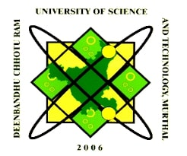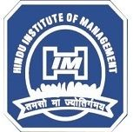––

Mobile: 8901440704, 8901440705

Credit: Shubham Dahiya

**BBA | BCA | MBA | MCA**

Courses offered:

10.03.2021

Announcement

Sports

HIM

**Web: www.himsonepat.org**

*The Sonepat Hindu Educational & Charitable Society, Sonepat*

Under the aegis of more than 100 years Old

(Affiliated to DCRUST, Murthal | Approved by AICTE, New Delhi)

**HINDU INSTITUTE OF MANAGEMENT, SONEPAT**